Create a graph class that stores an array of nodes, representing a unidirectional (directed) graph. Create a node class that stores a string, and up to 8 edges connecting other nodes.
Your program will take as input a file containing node names and links. Each line in the file will contain the name of a node, a node connected to it, and the distance. Names may be repeated for additional links. Example:
A B 10  A D 5  A E 10  D C 4  D F 4  C B 8  C F 3  F C 2  F E 8 | 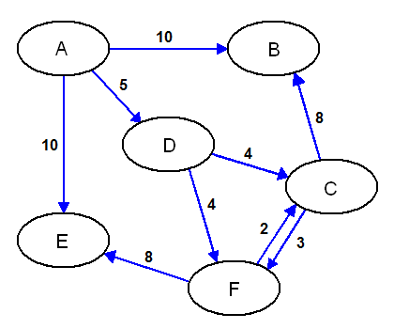
Use the following data files to test your program:
https://www.msu.edu/~bowmanm/231/Program07.zip
This file contains: Program07a.txt, Program07b.txt, Program07c.txt
The graph class should have the following data elements:
- Map An array of nodes
- N Number of nodes in graph
The graph class should have the following functions:
- Constructor Initialize the empty graph
- Insert Insert an edge into the graph. Takes three parameters, a value for the source node, a value for the target node, and the weight of the edge. If either of the values do not exist, add them to the node list.
- Depth Display the values of a depth-first search. Takes two parameters, the output stream, and the value of where to start the search.
- Breadth Display the values of a breadth-first search. Takes two parameters, the output stream, and the value of where to start the search.
- Find Return the array index of the node that matches. Takes one parameter, a string.
The node class should have the following data elements:
- Value Stored value
- Visit Boolean indicator shows if node has been visited
- Edge Array of pointers to other nodes
- Distance Array of edge weights
The node class should have the following functions:
- Constructor Create an empty node
- Put Output the value
- Connect Create an edge. Takes two parameters, a pointer to the target node, and the distance.
- Depth Recursive depth-first search.
- Breadth Add this node’s neighbors to a breadth-first list of nodes. This does not need to be recursive.
The value, visit, edge and distance arrays should be private to the node class. It will help to declare the graph class a friend to the node class.
Your class should also contain functions to search through the graph depth-first, and breadth-first. Use these functions to display the contents of the graph, as shown below:
Enter file name: Program07a.txt

D)epth, B)readth, Q)uit: D
Enter start node: A
Depth List
----------------
A
B
D
C
F
E

D)epth, B)readth, Q)uit: B
Enter start node: C
Breadth List
----------------
C
B
F
E

D)epth, B)readth, Q)uit: Q

Thank you!

What to Hand In
Hand in a copy of the code and a sample run for each of the input files to demonstrate that your program and functions work.

